2018 FCPS High School Voter Registration Challenge

Voting is a fundamental civic duty and right of all eligible U.S. citizens and one of the primary ways we make our voices heard. For youths who come of voting age, it is an important rite of passage. This Challenge aims to help ensure that the torch of civic engagement is passed on to the next generation of voters. We are each responsible for the health of our democracy.

How does someone register to vote online?
Go to lwv-fairfax.org/hschallenge/.
You will find a unique online registration link with your school’s name.

What is the Challenge?
We are challenging FCPS Schools to register eligible members of their senior class.

Upcoming Election: November 6, 2018

Voter Registration Deadline: Oct., 15, 2018

Find Your Voters’ Guide: VOTE411.org
What are the prerequisites for registering to vote in Virginia?

They include:
- Must be a U.S. citizen
- Must be 18 on or before the next General Election. Thus, 17 year olds born on or before November 6th, 2000 can register now!
- Must be a resident of Virginia
- Must have had their rights restored if they have committed a felony
- Must have had their rights restored if they have been judged mentally incapacitated by a Circuit Court

Sponsored By:
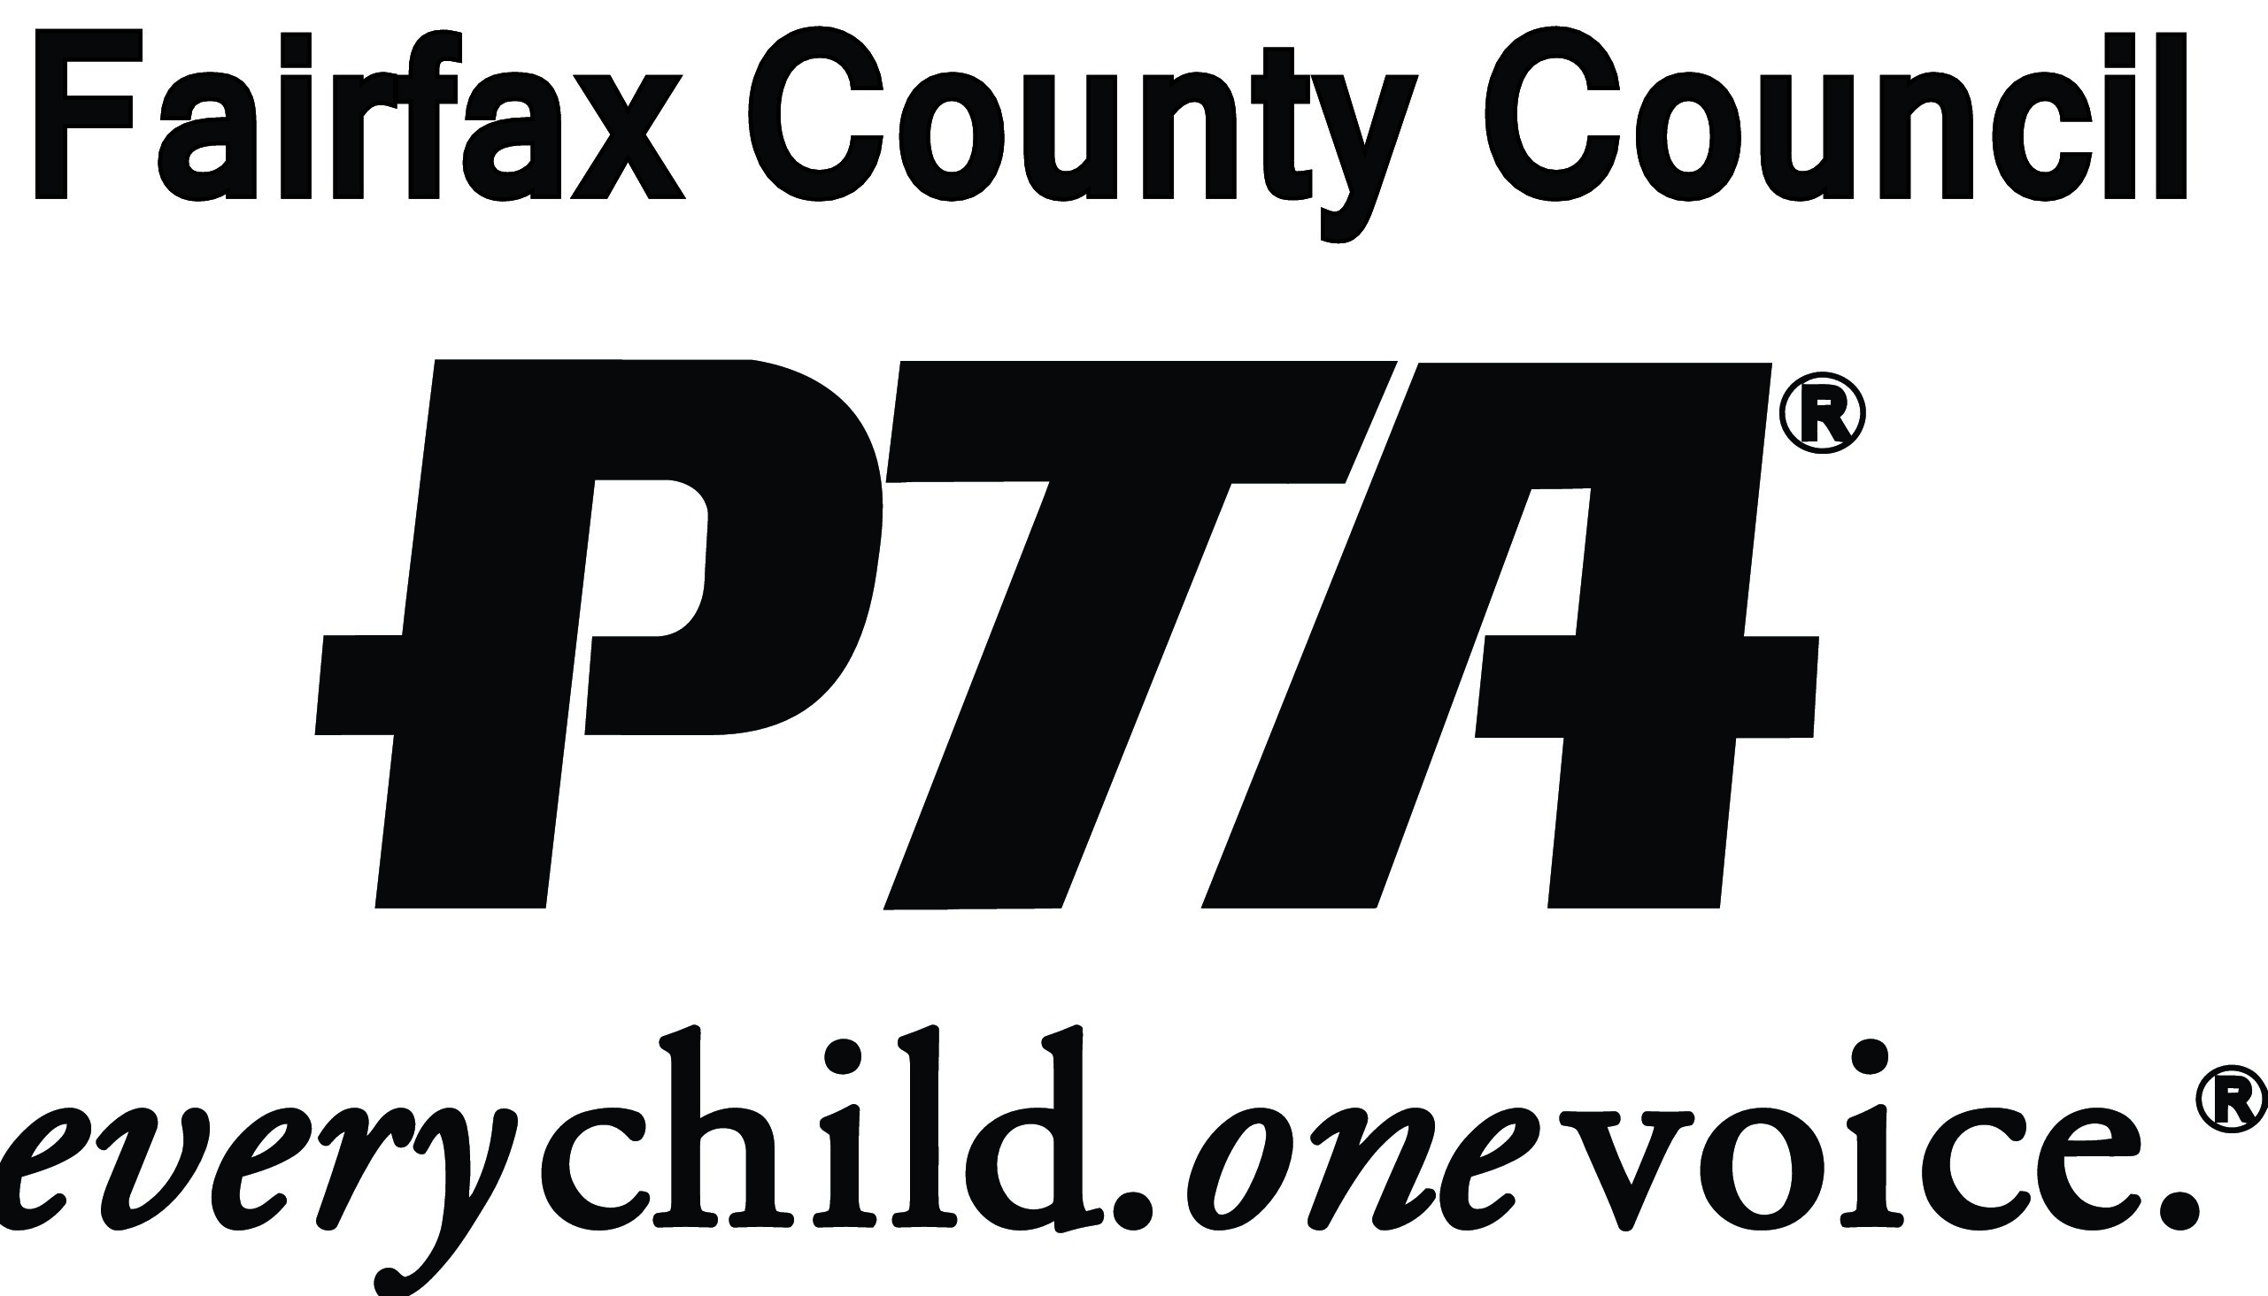

Need more information?

Please contact Beth Tudan, director@lwv-fairfax.org, Executive Director of the League of Women Voters of the Fairfax Area, or Nancy Roodberg, at Nancy.Roodberg@lwv-fairfax.org

For more information relating to voter registration: lwv-fairfax.org/voter-information/

lwv-fairfax.org/hschallenge/
Frequently Asked Questions
Q: Can I register to vote online?
A: Maybe! If you have a Virginia drivers’ or DMV Number from your learners’ permit, then yes. Otherwise, you can start the voter registration process online, then print out the form and mail it in.
You can find your high school listed here: lwv-fairfax.org/hschallenge/
Q: Can 17-year-olds register to vote in Virginia?
A: Yes! As long as they will be 18 by the next General Election in November, they can register to vote.
Q: OK, so many 17-year-olds can register, but can they actually vote in Virginia?
A: Sometimes! If they will be 18 by the General Election, then they can vote in a primary election or in a special election. For example, in 2016, 17-year-olds were able to vote in the Presidential Primary in March. In 2017, they were able to vote in the Special Election for the FCPS School Board. In 2018, they will be able to vote in the June 12th primary.
Q: What about students who are not US citizens?
A: Only US citizens can vote, so no, they cannot register. It would behoove any of us to test ourselves on the questions to become a US citizen: https://my.uscis.gov/en/prep/test/civics/view How did you do?
Q: Do I need an ID to vote?
A: Yes. See elections.virginia.gov/registration/photo-ids-required-to-vote/index.html
Q: Once I register, everything is set, right?
A: Well, let’s hope so. Look out for a post card from the Office of Elections with your precinct and polling place location. If it did not go through, you will receive a letter with your new application form. Check out your voter registration status online to verify that you are registered. Think of this process as an “application to register to vote.” Visit elections.virginia.gov/index.html
Q: Once I’m registered, can I vote anywhere I want?
A: Noooooooooooooooooooo! (Should we repeat that?! Noooooooooooooooo!). It’s not like an ATM. On Election Day, you have to vote in the precinct where you are assigned. If you are away in college and you change your voter registration there, you can only vote there. If you are still registered at home, then you can only vote in your home precinct. But DOUBLE, TRIPLE CHECK to verify your polling place! Don’t show up at the wrong place and be disappointed. Go to elections.virginia.gov/casting-a-ballot/absentee-voting/
Q: Can I vote absentee?
A: There are 20 reasons to vote absentee in Virginia. Being away in college is a valid reason. If you come home for fall break, you could probably vote on a Saturday at an absentee voting site in Fairfax County. Otherwise, you will need to apply for an absentee ballot.
And you know what you need to do with the absentee ballot? Fill it in, SEAL the envelope, SIGN the envelope, have a witness sign the envelope, and put a STAMP on it. Mail it way early, too, so that it is received by Election Day.
Heard of a stamp, but never actually used one? See store.usps.com/store/results/stamps/_/N-9y93lv
Q: What if I move?
A: Federal law requires the US Post Office to send a notice to the Office of Elections with any change of address. The Office of Elections will then send you a postcard verifying the change. Pay attention! This is a big reason that people end up having a problem with their registration.
Q: What about students whose parents are in the military and hold residency in other states. Should these students register to vote?
A: These students do need to talk to their parents to see where their parents would like them to register to vote, whether in Virginia or elsewhere.
Q: Where can students register in another state?
A: For students whose parents are residents of other states, visit the League of Women Voters' one stop shop for voter information, vote411.org/register
Resources: lwv-fairfax.org/voter-information/
For College Voters: lwv-fairfax.org/collegevoters/
Voters with Special Needs:
lwv-fairfax.org/voterswithdisabilities/

Absentee Voting:
lwv-fairfax.org/absentee-voting/

Virginia Citizens’ Portal: elections.virginia.gov/index.html

